**Chapter 1- Knowing the consumer and suitability**

1. Gathering Information

A1- Considering the consumer’s wants and needs

Consumer’s wants may include a wish to extend or change cover, a desire to reduce the overall cost of insurance or to make a change to their insurance policy.

Consumers needs may relate to their potential exposures (risks) and insurance requirements exist whether they are aware of them or not. The role of the advisor is to identify the needs and blend these with their wants in order to recommend the most suitable solution.

A2- Consider the consumer’s attitude to risk

* Risk appetite- measure of an individual/company’s willingness to accept risk
* Risk-averse- a desire to minimise the risks to which they are exposed, through risk mgmt or insurance
* Risk-seeking- a willingness to accept risk

Advisor needs to identify each consumer’s position on the scale; they must ask how large the excess the consumer is willing to bear to ascertain this.

A3- What information do we need from the consumer?

More detailed coverage on this in next chapters. Consumer, address, occupation, age, etc.

1. Considering insurers and insurance products

B1- Basis for insurer and insurance product recommendations

B1a- Price

This is the most obvious factor for deciding between, and recommending insurance especially motor

B1b- Levels of service and support

* Fact and comprehensive quotations
* Efficient claims handling and prompt payment of claims
* Fair approach to complaint resolution

B2- Advisors experience and judgement

Their knowledge of the market and products available; familiarity with different insurers approaches to types of risk. An advisor should at all times be up-to-date with any new developments or industry trends.

1. Presenting the recommendation to the consumer

C1- Statement of suitability

This must be provided for the following reasons:

* A product or service offered is considered suitable for the consumer
* Each of a selection of product options offered to consumer is suitable
* A recommended product is considered to be the most suitable product for consumer

Principals governing this statement of suitability are as follows:

* The advisor must offer the most suitable option from those available. For intermediaries this will include a fair analysis of the market or a limited analysis of the market
* Advisor must offer a product meeting more of the consumer’s needs than any other product. They can offer their pro opinion
* Genuine reasons for offering options rather than recommending a single product, the adviser must highlight all relevant diff in cover level, terms/conditions etc. So consumer can make an informed decision

C2- The form of the statement of suitability

Statement of suitability (‘Reason Why’) letter can be structured in different ways but must contain:

**Important notice- statement of suitability**

This is an important document that sets out the reasons why the product(s) or service(s) offered or recommended is/are considered suitable, or the most suitable, for your particular needs, objectives and circumstances

Adviser or regulated entity must sign and provide a copy to the consumer and retain a copy, at the time the quotation is being offered.

**Chapter 2- Motor insurances**

1. The compulsory nature of motor insurances

Due to the compulsory nature of motor insurance, Insurance Ireland operates the Declined Cases Agreement. This is to ensure that the insurance market will not refuse to provide insurance to an individual seeking cover. Consumer must try to get insurance from 3 different insurers.

1. The scope of motor insurance policy cover

Motor I tend to be subject to limits of indemnity (insurers max liability for any 1 incident- Set @ high levels). Cover of vehicle is generally based on market value rather than sum insured. Premiums are based on several exposure measures:

* Vehicle(make, model, year, value)
* Driver (age, occupation, licence type previous claims/accidents)
* Location of use
* Cover required
* Use of vehicle

B1- Road Traffic Act cover (RTA)

This is the min level of cover required by law. Applies throughout Ireland and EU and must provide cover indemnity for:

* Bodily injury/death caused to 3rd parties, inc passengers- unlimited amount
* Loss of, or damage to property belonging to 3rd parties min of €1.22m per claim
* 3rd party claimants’ cost and other expenses of handling claims
* Emergency treatment for 3rd party injuries caused by or arising from RTA liability
* Liability arising from trailers attached to or becoming detached

RTA cover is restricted to the use of vehicles ‘in a public place’. It covers the purpose of ensuring that even those considered high rick drivers have the most basic motor insurance cover. It is only recommended and issued in exceptional circumstances e.g. young driver who has never driven, a driver in breach of policy conditions or convicted of motoring offences.

B2- Third party only cover (TPO)

In addition to the above cover, TPO policies provide indemnity to the following:

* Anyone driving the vehicle with permission, if allowed on the certificate
* Anyone using the vehicle (i.e. a passenger)
* An employer or partner, if the use is covered under the policy
* The owner of the vehicle or their personal representatives
* The hirer of the vehicle (for the negligent acts of the policy holder)

TPO policies also cover:

* 3rd party emergency treatment where required by law
* Liability arising from loading and unloading the vehicle- driver and attendant
* Higher 3rd party property damage limit per claim (€30m is a standard limit)
* Legal representation at any inquest or fatal injury enquiry, or to defend a charge e.g. of manslaughter- €1,300 limit
* Unlicensed drivers (where a licence is not required by law and the person is old enough to drive)

Driving of other cars- extension of cover whereby a policyholder may drive a third party’s vehicle. In certain situations this extension is referred to as ‘driving of other cans’ or ‘driving of other commercial vehicles’. It is restricted to 3rd party cover regardless of the cover held, this cover can be upgraded for an additional premium. The extension will only provide cover where none already exists under another policy and it applies to private cars only, to avoid the extension being used to ‘insure’ multiple vehicles or uninsured vehicles.

TPO cover excludes:

* Any loss or damage to the insured vehicle or the insured’s property
* Use other than for the business activates of the policyholder
* Anyone insured under another policy

B3- Third party, fire and theft cover (TPF&T)

* Fire (including self-ignition, lightning or explosion)
* Damage during an attempted theft or while it is stolen
* If stolen but not recovered

TPF&T cover excludes:

* Theft or attempted theft if keys are left unsecured or in/on an unattended car
* Depreciation, wear and tear
* Mechanical/electrical fault or derangement
* Malicious damage or vandalism
* Breakage of windscreen and window- can be purchased as optional extra

B4- Comprehensive cover

Adviser must ensure that their client fully understands the meaning of the term ‘comprehensive’. While the policy provides a considerable level of protection, it does not provide cover against every risk.

In addition to TPF&T cover, the policy also covers:

* Replacement/”new for old” cover. If less than 1 year, hasn’t exceeded certain mileage and repair costs exceed 50/60% of current list price, a replacement of the same make, model and spec is provided
* Spare parts and accessories kept in, or on the vehicle or in the policyholders private garage- limited to market value or PH’s estimate, whichever is less
* Radios up to 5% of vehicle or €750 (typical), whichever is less
* Breakage of glass in windscreen or windows (ex sunroofs), which may be subject to a limit and (possibly) an excess, but does not affect the no claims discount (NCD)

This policy excludes the following as in most other policy types:

* Depreciation, wear and tear
* Mechanical/electrical fault or derangement
* Isolated damage to tyres- punctures, blowouts
* The cost of hiring a replacement vehicle
* Los/damage from putting wrong fuel in a vehicle
* Import costs of parts outside the EU
* Loss/damage from using the vehicle in a rally, competition or any race track/circuit

B4a- Additional benefits

Some additional benefits that may be included in comp cover can include

* Driving of other cars
* Roadside/driveway assistance
* Courtesy car
* Personal accident- any person insured under the policy is seriously injured
* Medical expenses/Personal effects

1. The class of use

* Class 1(a)- Social, domestic and pleasure use only- Covers policy holder/spouse commuting to and from their usual place of work
* Class 1(b)- including use for business by policyholder only with limited business mileage (1k-5k per year)
* Class 2- permits the carriage of goods or samples (unlike above) belonging to the policyholder or their employer, and for other drivers named on the certificate of I to use the vehicle for the business of the policyholder
* Class 3- this permits class 2 use, but also permits **commercial travelling-** where driving is a permanent aspect of the policyholders job and they are selling goods or services while on the road

Class 1(b), 2 and 3 also allow for use for social, domestic and pleasure purposes.

1. Policy exclusions and conditions

D1- General Policy conditions

Main general conditions are as follows:

* There is a continuing duty on part of the PH to disclose all material facts to their insurer. PH must inform insurer of changes to risk during period of I e.g. change of vehicle, address or job
* Vehicle must be maintained and roadworthy and have a valid NCT where applicable
* Insurers are entitled to seek recovery from PH of sums they have been obliged to pay by virtue of legislation
* Insurer is entitled to cancel a policy by giving notice in writing to PH
* Any dispute over policy cover must be referred to arbitration
* Fraud or deception. Most insurers will include a condition of fraud or deception, which outlines that they may void or cancel a policy in the event of underwriting fraud

D2- General Policy exclusions

* Use of the insured vehicle outside of the classes in section C
* Contractual liability
* Radioactive contamination
* War and kindred risks
* Racing, pace making
* Terrorism, earthquake, riot or civil commotion, sonic bangs

1. No claims discounts

E1- Types of NCDs

E1a- Step back arrangements

A cushion against the effects of claims where the NCD is only partially reduced for every claim made. An insurer may apply a 2-year step-back arrangement (e.g. 5 years NCD is ‘stepped back’ to 3 years).

E1b- Protected NCD

NCD generally available once PHs have reached their maximum entitlement on the insurer’s NCD scale- usually 2 claims on a 3-year period.

E1c- Guaranteed NCD

NCD that cannot be taken away no matter how many claims are made. If PH has a bad record the insurer may increase the basic rate or decline to renew the policy. When transferring to another insurer they will be aware of all claims in its confirmation of claims experience.

1. Questions to ask the consumer and why

An advisor may wish to get a better understanding of the proposers ‘use’ of the vehicle. There are a number of factors to take into account regarding pricing and underwriting- process of risk pooling, selection and assessment of individual risks that meet the insurer’s risk criteria:

* Proposers name and address
* Driver(s) details
* Vehicle(s) type and details
* Use of the vehicle(s)
* Cover required

1. Motorcycle insurance

G1- The motorcycle insurance market

Sale of motorcycle insurance may be limited to more experienced or specialised advisers. Also, the fact that many of the major insurers do not write this business al all means that choices available may be very limited.

G2- The motorcycle insurance policy

The format of the motorcycle policy is much the same, although simpler than the private motor policy. 3rd party only cover, which covers the insured’s legal responsibilities to 3rd parties only, is the min level of cover provided.

Comprehensive, fire and theft

* Loss of, or damage to the bike is covered, subject to excess
* Cover for damage to, or theft of, spare parts and accessories only applicable if they are on/ in the bike, or kept in a locked private garage, & only if the bike is stolen at the same time
* Cover is limited to market value or PHs estimate, whichever is lower
* Some insurers offer an agreed value- sum insured as agreed @ the beginning of the period of I and paid in respect of a total or partial loss claim as usually defined in the policy

Comprehensive Cover

There may be extensions available or automatically provided for:

* Side cars, trailer
* Indemnity to employer
* Driving other cycles (3rd party only)
* Breakdown and recovery
* Legal protection cover

Examples of excluded benefits

* Personal accident benefits
* Medical expenses
* Personal effects

NCD earned under a MC policy is not normally transferable to a private car insurance policy. Often the scale used is @ a lower level, e.g., for MC I, the top of the NCD scale could be 50%, while for cars it could be up to 75%.

1. Guaranteed asset protection insurance (GAP)

This covers the difference between the motor policy claim and either:

* The value of the car at the time the GAP insurance was purchased (return to value), or,
* The invoice price originally paid for the car (return to invoice)

The reason for this is that the I payout may not be sufficient to cover other financial liabilities the PH may have in relation to the car (car loan, or HP agreement). It helps avoid negative equity. Usually sold as a standalone policy and usually sold by a motor trader in conjunction with the sale of the car

Cover will not apply when:

* Theft or ‘writing off’ not covered under the insured’s policy
* Motor insurance offers to provide a replacement vehicle as settlement of the claim

Typically underwriting criteria include the following:

* Car must normally be less than 7 or 8 years old
* The car must normally have been purchased from a dealer no more than 3 months before the GAP policy is arranged
* The car must be of an Irish spec, and must not have non standard modifications
* The recorded annual mileage on the car must be no more than a specified amount e.g. 80,000 or 120,000kms

**Chapter 3- Household insurances- definitions, insurable values and information gathering**

1. Defining ‘buildings’ and establishing an insurable value

A1- Defining ‘buildings’

Different insurers define the term ‘buildings differently. Insurers usually define two terms in their policy document- ‘the home’ and ‘buildings’.

* The home- the private house, bungalow, flat, maisonette or self-contained purpose-built apartment at the address shown in the schedule
* Buildings- outbuildings, fixtures & fittings, swimming pools, greenhouses, terraces, footpaths, patios, drives, walls, fences & gates within boundary of the home

There are differences of approach in relation to items such as interior decorations, tennis courts, decking, hedges and septic tanks

A2- Defining ‘standard construction’

Insurers pay close attention to the construction of buildings and create a range of rates for ‘normal’ ricks. In case of household buildings, the fabric of the building is assumed to be fire-resistant and reasonably substantial. Flimsy construction (timber walls) or corrugated plastic roofing, for example will impact not only on the fire peril but also on theft, storm and flood.

As a general rule, when differentiating between was is classed as ‘buildings’ and ‘contents’, anything that the insured would normally leave behind when moving house can be regarded as buildings e.g. fitted kitchens, sanitary ware, windows etc.

A4- Establishing insurable values for buildings

The basis for setting sums insured is normally the full cost of rebuilding the property. Insurer will settle without making a reduction for wear and tear, depreciation etc, provided the building is in good repair. Other factors to consider include:

* Boundary walls
* Garages
* Fitted kitchens
* Outbuildings
* Swimming pools
* Drives- allowing for concrete pathways
* VAT

Specifically excluded from the guide are:

* Properties with more than 2 storeys or basements or habitable attics
* ‘one-off’ houses with special design features or period houses
* Apartments/residential flats, because of split responsibility for shared areas

Renovations such as new extensions, expensive flooring or fitted kitchens are all likely to increase rebuilding costs, particularly of any specialised materials are used.

A4a- relevance of market value

For a few reasons, the market value of a property is not a good basis for valuation, as this value includes the cost of the land which is irrelevant for rebuilding purposes.

A4b- Index linking

This is the method of calculating the sum insured on buildings and contents that is adjusted monthly in line with appropriate indices, but in times of very low inflation may be set at ‘nil’

1. Defining ‘contents’ and establishing an insurable value

B1- Defining ‘contents’

* Contents- household goods, personal belongings and valuables (including personal money up to limit in schedule) within your home that you or any member of your family own or for which you are responsible
* Credit & debit cards- including charge, cheque, bankers’ or cash dispensing cards
* Home office equipment- PC, printers, fax, telephone etc are included for a specified amount in any one period of time
* Money- cash, cheques, postal orders, bank drafts, travel tickets, saving stamps, premium bonds, gift tokens, luncheon vouchers etc
* Valuables/Valuable property- jewellery, items of gold, silver or other precious metals, watches, cameras, binoculars, paintings, works of art, antiques, furs, musical instruments, TVs ( amt usually subject to a limit on what an insurer will pay under a valuable property claim)

B2- Establishing insurable values for contents

The basis for setting the sum insured on contents should be the full cost of replacing the contents, as new, after allowing for deterioration on items not covers on a ‘new for old’ basis.

For owner-occupiers, there are variations in arriving at a sum insured- 2 different approaches.

* The sum insured is selected by the consumer
* The insurer offers a choice of contents insured amounts representing a % of the buildings sum insured

Underinsurance- policy that has been effected, requiring full value as the basis for the cover but where a lower figure has been declared. Insurers reduce claim payments in this case in different ways e.g.

* Pro-rata average condition and therefore reduce any claim payment in proportion to the amount of underinsurance, e.g. declared value of an insured item is 20% less than value of item, insurers can reduce the claim payment by the same amount
* Deduction for wear and tear in such instances

Whichever method is used to arrive at the insurable values for contents, it is imperative that the sum insured is adequate- meaning calculated on the total values that would be paid out for a claims settlement. An ideal method is a room-by-room approach and insurers provide a template to assist.

Index linking of the contents sum insured operates in a similar way to buildings (as above). Contents figure is normally adjusted monthly in line with the ‘Durable Household Goods’ section of the Consumer Price Index issued by the Central Statistics Office. This adjustment:

* Is typically subject to a minimum increase of 5%
* Continues after any insured loss or damage, if the repairs or reinstatement are carried out without delay

1. Questions to ask consumer and why

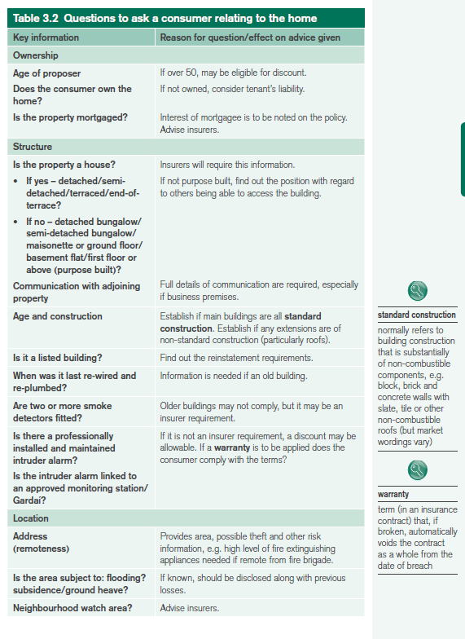

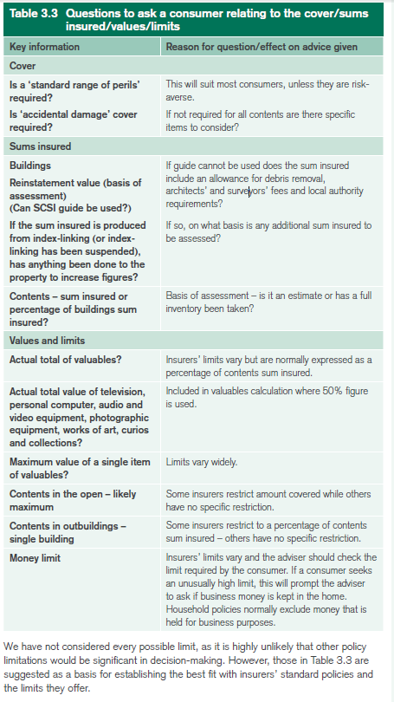

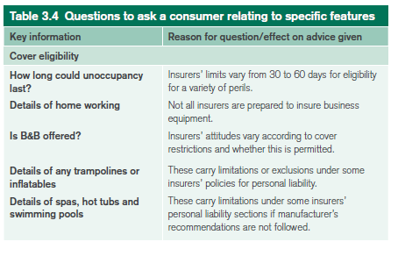

C1- No claims discount

Typically insurers offer NCD’s for successive claims-free years on a household I policy. E.g. 10% for 1y, 20% for 2y, 30% for 3y. This is to encourage loyalty

**Chapter 4- Household insurances**

1. Perils insured under a household buildings & contents insurance policy

It is important for students to memorise and understand all of these perils as they are essential part of the study and exam preparation.

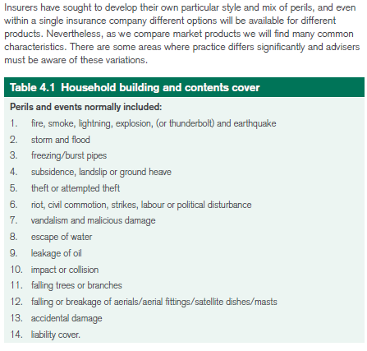

A1- Fires, smoke, lightning, explosion (or thunderbolt) & earthquake

All loss or damage resulting from above is covered in this section. Excludes:

* Smoke damage caused by fireplaces
* Smoke damage from agriculture or industrial operations

A2- Storm & flood

The frequency and cost of weather-related events in recent years has resulted in several insurers being reluctant to cover fold risks for properties prone to such damage. They have increased the flood damage excess to multiples of the standard excess. Exclusions for damage caused by:

* Frost, subsidence, ground heave (movement occurring when ground that had previously had a low moisture content suddenly absorbs moisture) or landslip (a rapid downward movement under the influence of gravity, of a mass rock or earth slope)
* To gates, fences or hedges
* By wear and tear or gradual deterioration

A3- Freezing/burst pipes

Frost damage that causes a burst pipe is covered i a standard household policy. All resultant damage (water damage) is also covered, but damage to the pipe itself is not covered.

A4- Subsidence, landslip or ground heave

Exclusions:

* Caused be settlement (common occurrence in new builds where the ground compacts beneath the foundations to accommodate the pressure of the new property)
* Caused by building on made-up ground or filled in land
* To walls, gates, fences, hedges, terraces, patios, drives, paths and tennis hard courts, unless the policy covers damage to the home from the same cause occurring at the same time
* To solid floors unless the foundations beneath the walls are damaged at the same time by the same cause
* To the contents, unless the policy covers damage to the home from the same cause, occurring at the same time
* Caused by subsidence or ground heave, but arising prior to the period of I in which a claim may arise
* Or destruction, if any part of the buildings suffered previous damage by this peril, unless the previous damage has been disclosed to, and accepted by, the insurer

A5- Theft or attempted theft

Insurers normally exclude loss or damage caused:

* While part of the home is lent, let, or sublet, unless entry to/from home is forced/violent
* By a member of the household( child taking money from parents wallet) other than household staff

A6- Riot, civil commotion, strikes, labour or political disturbance

Cover usually excludes loss or damage to:

* Boundary walls/hedges
* Tennis courts and pools
* Gates/fences and driveways
* Lawns and trees, shrubs, plants

A7- Vandalism and malicious damage

Damage caused by someone lawfully on the premises (tenant) is not normally insured

A8- Escape of water

This covers damage resulting from the escape of water from:

* Any fixed domestic water or heating installation (or the bursting of same)
* Any washing machine, dishwasher, refrigerator, freezer or fixed fish tank

Typically damage to the actual component or appliance is not covered, or damage to walls, ceilings or tiles by water seeping through grouting or seals. Insurers may impose a higher excess to this peril ranging between €500 and €1,000.

A9- Leakage of oil

Covers PH for all material damage- physical loss or damage to property.

A10- Impact or collision

Covers collision/impact by any aircraft, other aerial devices, road or rail vehicles.

A11- Falling trees or branches

The cost of removing any fallen trees/branches is also covered. Policies normally exclude:

* Damage to gates, fences or hedges
* The cost of replacing tree(s)

A12- Falling or breakage of aerials/aerial fittings/satellite dishes/masts

Damage to the equipment itself is usually limited to a specified amount- typically €700 - €1,000.

A13- Accidental damage

This covers damage to buildings and contents at the insured premises, unless specifically excluded. The main exclusions relate to:

* Damage caused by the PHs pets
* Damage while the home or any part of the home is lent, let or sublet
* Jewellery, watches, furs, contact lenses, hearing aids, mobile phones or computer equipment designed to be portable, while it is being transported, carried or moved (unless the loss or damage occurs within the property insured)
* Any loss or damage or amount shown as not insured under the various perils listed in Sections A1-12

Some insures automatically provide accidental damage cover in buildings section of a policy. However, lost give the PH the option of choosing standard perils or accidental damage cover for both building and contents.

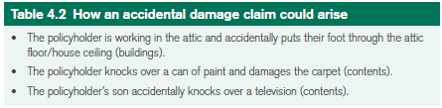

A14- Liability cover

Liability cover provides protection in situations where the PH (or a member of the household) may be legally responsible for an injury to a third party or damage to their property. Cover is restricted to liabilities connected with the insured’s ownership or occupation of the home, and their activities as a private individual. For all policy sections, the most that will be paid for any claim or claims arising from 1 event varies between €1.3m and €3m. This max amount is referred to as a limit of indemnity- insurer’s maximum liability for any one incident/claim (usually under the terms of a liability policy or section of a policy).

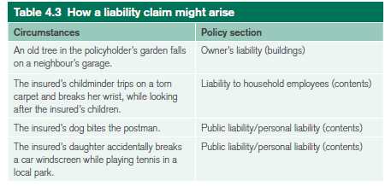

Where a property is rented, the liability for the property remains the responsibility of the landlord/property owner. Tenants are responsible for their own liabilities and must arrange their own insurance policy. Where tenants have their own contents insured, the liability cover is included on the policy.

1. **Additional cover and benefits automatically included**

B1- additional cover and benefits under the buildings section

Household buildings policies also contain a number of clauses that extend the protection provided by the main perils listed in the policy:

B1a- Accidental breakage of fixed glass or sanitary fittings

Accidental breakage of sanitary ware & fixed glass in windows, doors and solar panels is insured under this benefit. Also includes accidental damage to plate-glass tops, fixed glass in furniture, glass shelves, ceramic hobs and mirrors, if such elements are in fixed items that normally form part of the buildings. Typically, damage caused by vandals or people unlawfully on the premises are not insured under this policy section.

B1b- Accidental damage to pipes and cables

Damage to cables, underground pipes/tanks are covered. This cover applies under both standard and accidental damage policies.

B1c Architect, surveyor, legal and other fees and associated costs

Costs necessarily incurred following damage by an insured event, provided adequate provision has been included:

* Architect, surveyor and legal fees
* The cost of sharing up, demolishing/dismantling any part of the buildings, and removing rubble/debris
* The cost of meeting current building regs relating to the damaged portion of the building

B1d- Trace and access

In the event of damage by water/oil leaking from any tank, apparatus or pipe, the PH may need to trace and access the source of the damage before repairs can commence. When cover is provided, either an increased excess may apply, or the insurer may limit is exposure to a max amount- usually r may limit is exposure to a max amount- usually $2,000.

B1e- Fire brigade charges

These charges relating to the controlling/extinguishing of a fire that is affecting (or threatening to affect) the building are covered, provided that the circumstances that gave rise to the fire are covered under the policy. Max amount typically ranges between €1,500 and €2,000.

B1f- Rent/alternative accommodation

Insurer will normally pay for the following if the home is made uninhabitable:

* Rent receivable or payable by the PH
* The reasonable extra cost of comparable alternative accommodation
* The reasonable cost of temporary storage of furniture

The most an insurer will typically pay under this policy section is approx 15-20% of the buildings/contents sums insured.

B1g- Selling your home

If the PH is selling their home, the insurer will provide indemnity to the buyer up to the date the contract is completed, unless they have arranged their own I.

B1f- Title deeds

Costs of preparing new deeds to the property are covered, while in the home or while kept in the PH’s bank for safe-keeping.

B1i- Door lock replacement

Cost of replacing and fitting outside door locks to the home, if the keys are stolen, following a break-in or following an assault on the PH or a member of their household, is typically covered. The most an insurer will pay is around €650.

B2- Additional cover and benefits under the contents section

B2a- Accidental breakage of mirrors or glass

Occurring in the home, of mirrors, plate-glass tops to furniture, fixed glass in furniture or ceramic hobs is covered.

B2c- Accidental damage to audio equipment

All household policies cover this if occurring in the home. Included are radios, TVs. Other audio or video equipment and computer equipment up to a limit of €1,300 - €1,500.

B2c- Personal money

This cover accidental loss of, or damage to, money belonging to the PH or a member of their family, anywhere in the world, for an amount in the region of €650 - €1,000. A lower excess of €50-€100 usually applies to loss/damage under this section. Most insurers do not charge an extra premium for money and credit cards cover.

B2d- Credit cards

Household policies usually cover financial loss following unauthorised use of credit cards belong to PH or member of family. Limit of indemnity is approx €650-€1,000.

B2e- Freezer or refrigerator contents

Usually cover deterioration of food or drink caused by:

* A change in temperature of the freezer or fridge in the home
* Contamination by accidental escape of refrigerant or refrigerant fluids

Cover tends to be on a strictly indemnity basis, replacing food/drink unfit for consumption to €500

B2f- Contents temporarily removed

Contents are insured within the geographical limits stated in the policy, while temporarily removed from the premises, against loss or damage caused by:

* The perils number 1-3 and 5-12 in section A
* Theft or attempted theft

There is usually a monetary limit on the insurer’s liability under such a clause e.g. 15% of the contents sum insured

B2g- Removal by professional furniture removers

Accidental loss/damage to contents while a) they are being moved by professional furniture removers to the PH’s new home (within the geographical limits) or b) while in temporary storage (up the 7 days in a furniture depository)

B2h- Leakages

Following accidental damage to the domestic water/heating installation, following are covered:

* Oil from a domestic heating installation
* Metered water

Loss of central heating oil is usually insured to €650. Cost of trace & access also provided under most policies. Loss or damage due to wear and tear is not covered and the property must not be unoccupied for a specified number of days.

B2i- Title deeds

As outlined in Section B1h.

B2j- Fatal injury/compensation for death

This covers fatal injury to the PH and/or spouse or partner as a result of:

* Fire, accident or assault in the premises
* An accident while travelling within the geographical limits as a fare-paying passenger in any road or rail vehicle
* Assault in the street, within the geographical limits, provided death follows within 12 months of injury

Max amount payable by the insurer in respect of 1 incident is approx €30,000

B2k- Extra contents cover at Christmas

Some insurers will typically increase the contents sum insured by 10% for December and January to provide cover for gits, food and drink.

B2l- Wedding presents

Contents sum insured is automatically increased by 10% to insure wedding gifts 1 month before and after the wedding day of the PH or a member of their family

B2m- Contents in the open

Contents are insured while in the open, within the boundaries of the land belonging to the home, against loss/damage caused by peril 1 and perils 4-12. The most an insurer will pay under such a clause is approx €650. Generally this extension is provided to offer limited cover on garden/patio furniture.

B2n- Jury service expenses

Some insurers will pay €25 per day to a max of €700 in any 1 period of I for PH or spouse. No excess applies and a claim for such expenses will not affect the NCD.

B2o- Visitors and guests property

Loss of, or damage to property of visitors and guest (other than paying guests) by an insured cause is included under this extension. A limit of €1,000 per any 1 loss applies.

1. **Optional extensions**

C1- Personal possessions outside the home (‘all risks’)

C1a- Summary of cover provided